18-PST-044

27/8/18

**FITTING OF A BINOMIAL DISTRIBUTION**

EXERCISE 24:

**AIM**

To test fitness of good of a given binomial distribution.

PROBLEM1: Test the goodness of fit for binomial distribution of five coins are tossed simultaneously for 1000 times at 5% level of significance.

|  |  |  |  |  |  |  |
| --- | --- | --- | --- | --- | --- | --- |
| X | 0 | 1 | 2 | 3 | 4 | 5 |
| F | 38 | 144 | 342 | 287 | 164 | 25 |

**R CODE AND OUTPUT**

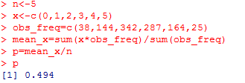

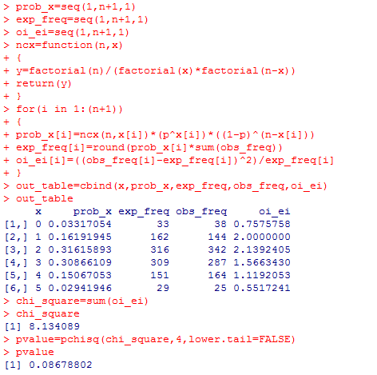

**INTERPRETATION**

Value of p=0.08678802 is greater than 0.05 so we are not rejecting the null hypothesis. The chi_square value is value for test statistic with 4 degrees of freedom.

PROBLEM2: Four coins are tossed for 100 random repetitions.Fit the binomial distribution and test it at 5% level of significance,when the coins are unbiased?

|  |  |  |  |  |  |
| --- | --- | --- | --- | --- | --- |
| X | 0 | 1 | 2 | 3 | 4 |
| F | 7 | 18 | 40 | 31 | 4 |

**R CODE AND OUTPUT**

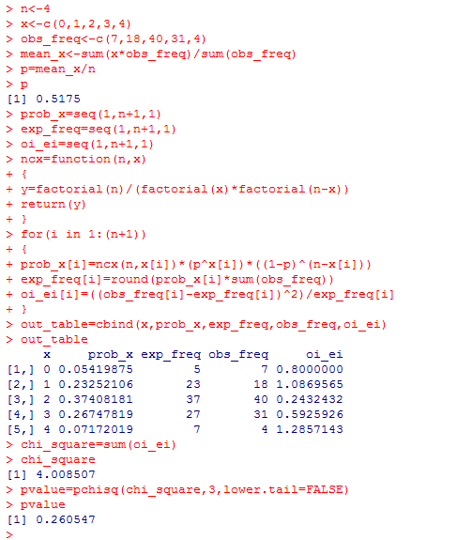

**INTERPRETATION:**

Value of p=0.260547 is greater than 0.05 so we are not rejecting the null hypothesis. The chi_square value is test statistic with 3 degrees of freedom.

18-PST-044

27/8/18

**FITTING OF POISSON DISTRIBUTION**

EXERCISE 25:

**AIM**

To understand the fitting of poisson distribution and also to test its goodness of fit at given level of signifcance.

PROBLEM1:A set of five identical coins is tossed 320 times and the number of heads appearing in each time is recorded.

|  |  |  |  |  |  |  |
| --- | --- | --- | --- | --- | --- | --- |
| No.of heads | 0 | 1 | 2 | 3 | 4 | 5 |
| Frequency | 14 | 45 | 80 | 112 | 61 | 8 |

**R CODE AND OUTPUT**

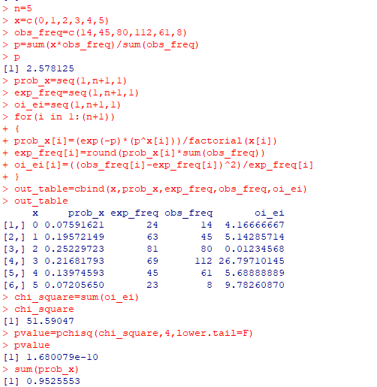

**INTERPRETATION**

The value of p is 1.680079e-10 is less than 0.05. Hence we reject our null hypothesis. Here chi_square value is our value for test statistic with 4 degrees of freedom.

PROBLEM2**:**Fit the given data to poisson distribution and test the goodness of fit for the distribution?

|  |  |  |  |  |  |  |  |
| --- | --- | --- | --- | --- | --- | --- | --- |
| X | 0 | 1 | 2 | 3 | 4 | 5 | 6 |
| F | 4 | 14 | 23 | 23 | 18 | 9 | 9 |

**R CODE AND OUTPUT**

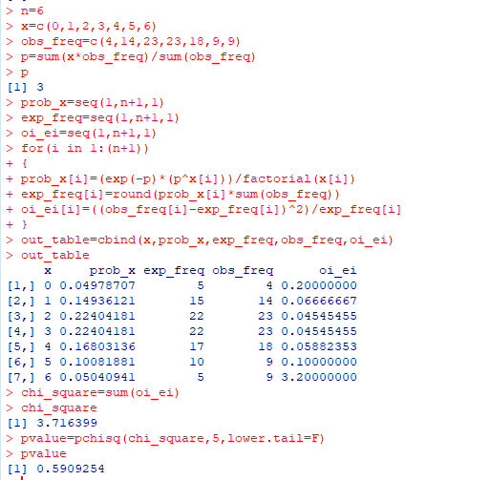

**INTERPRETATION**

Here we check our null hypothesis at 5% level of significance. Value of p =0.5909254 is greater than 0.05.Hence we does’nt not reject our null hypothesis. The chi_square value is our value for test statistic with 5 degrees of freedom.